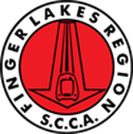
Finger Lakes Region Sports Car Club of America Guideline

Guideline Title:
Drafted by:
Approved:
Approved by:
Next Review Date*:
*should be no longer than two years from approval date and limited to January and July of the calendar year.
Guideline Brief Description:

Guideline Details:

Additional Comments:

Attachments:

